**AWS ECR**

Amazon Elastic Container Registry (Amazon ECR) is an AWS managed container image registry service that is secure, scalable, and reliable.

You can use your preferred CLI to push, pull, and manage Docker images, Open Container Initiative (OCI) images, and OCI compatible artifacts.

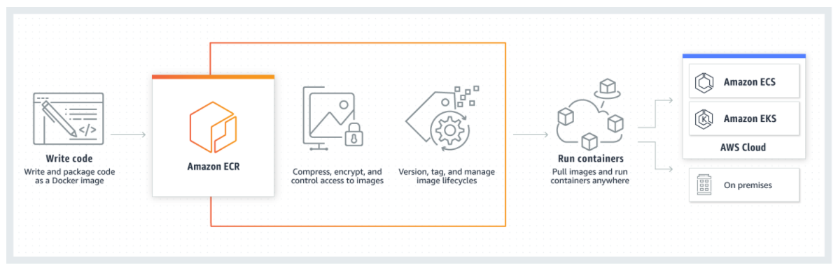

Registry

An Amazon ECR registry is provided to each AWS account; you can create image repositories in your registry and store images in them.

Repository

An Amazon ECR image repository contains your Docker images,

Repository policy

You can control access to your repositories and the images within them with repository policies

Registry/Repositories

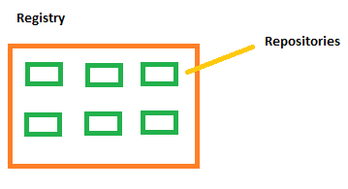

1. Create a repository

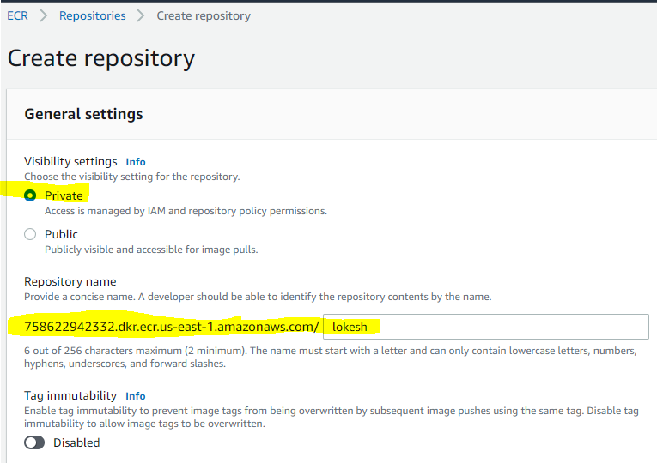

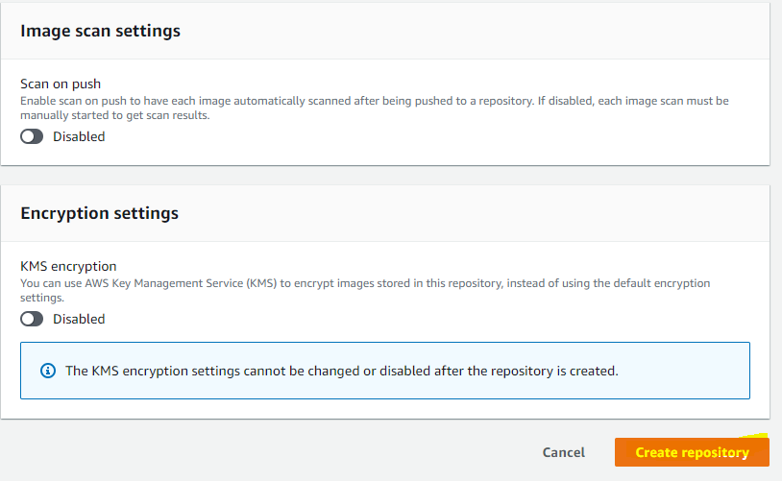

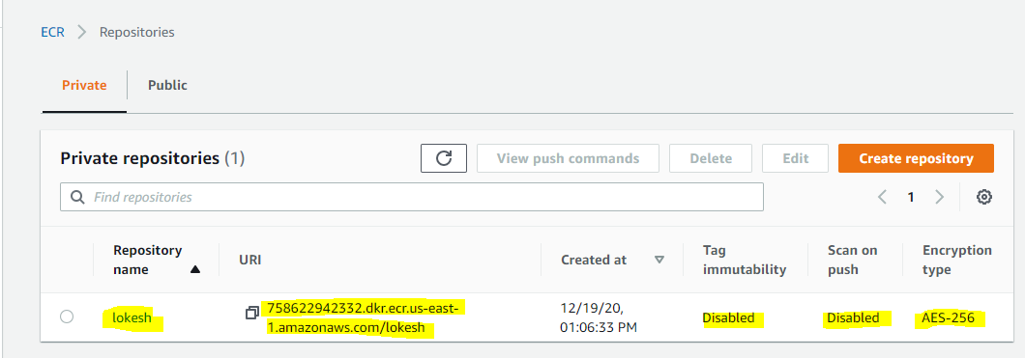

1. Create a IAM user with only programmatic access
2. Install AWS CLI
3. Execute below commands provided by ECR

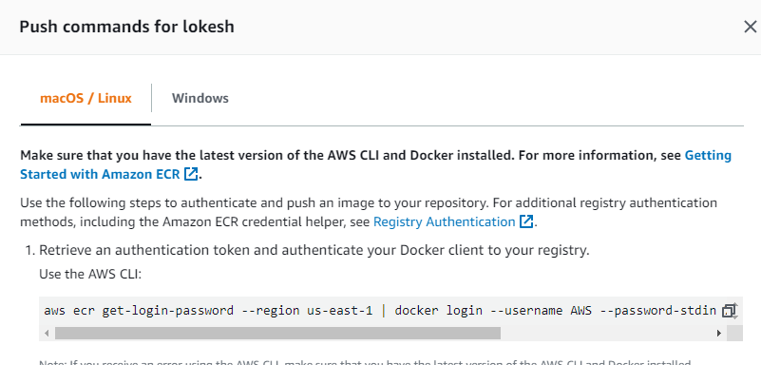

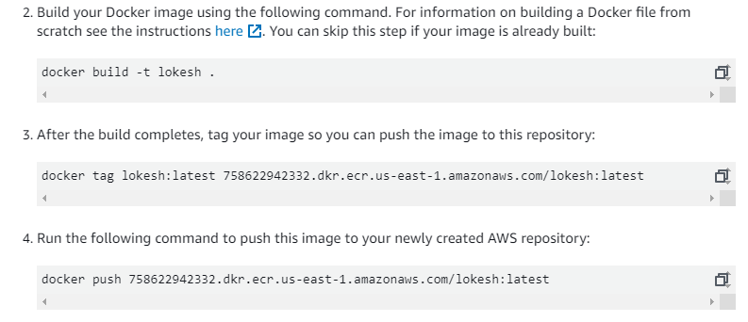



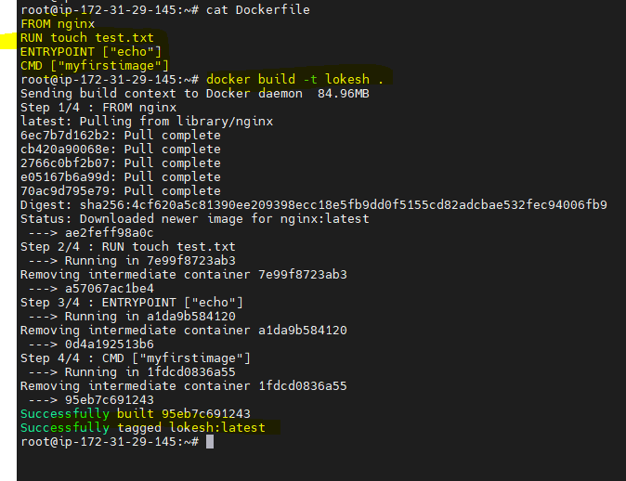



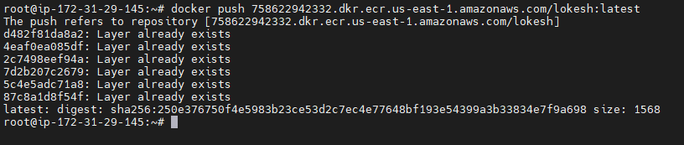

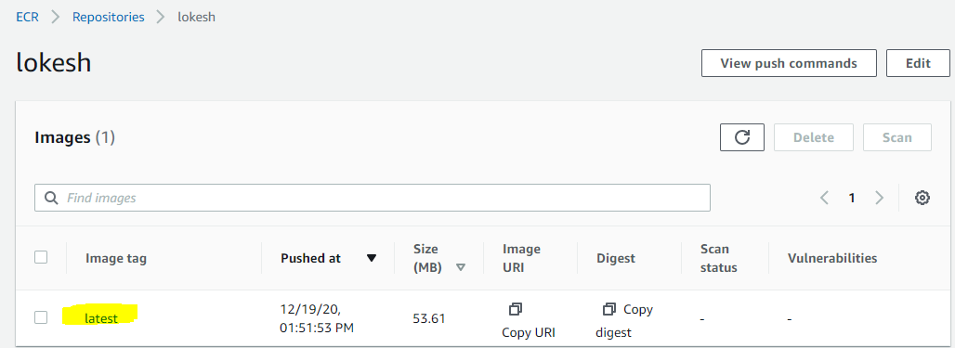

**EKS::: Elastic kubernetes service**

Amazon elastic container service for kubernetes is a managed service that makes it easy for you to run kubernestes on AWS without needing to install, operate, and maintain your own Kubernetes control plane or nodes.

**Advantages:**

1. No need to manage control planes and master
2. Secure by default
3. Compatible with standard kubernetes

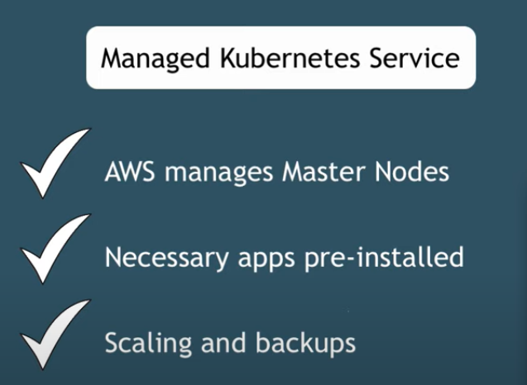

https://towardsdatascience.com/kubernetes-application-deployment-with-aws-eks-and-ecr-4600e11b2d3c

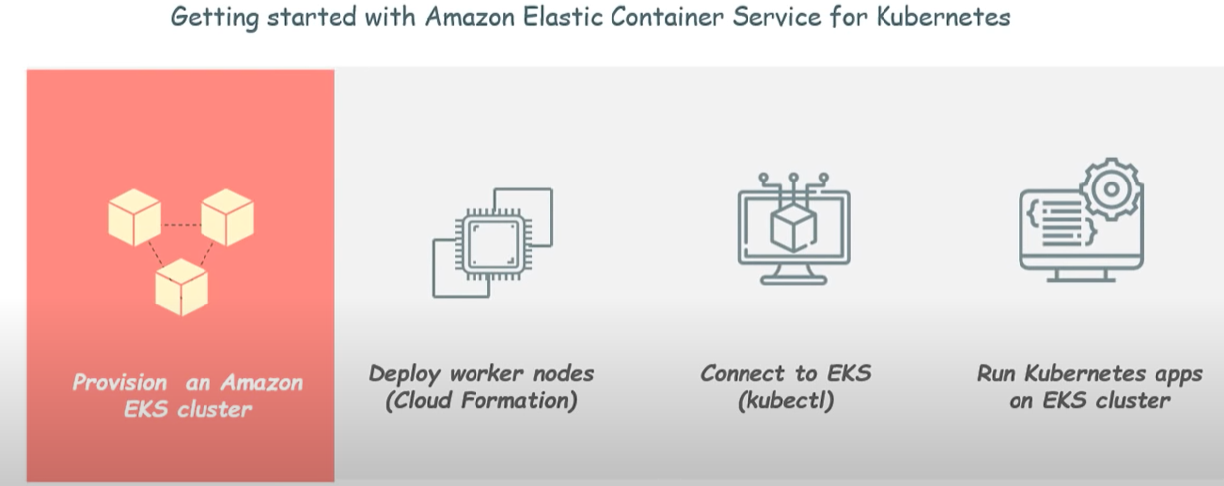

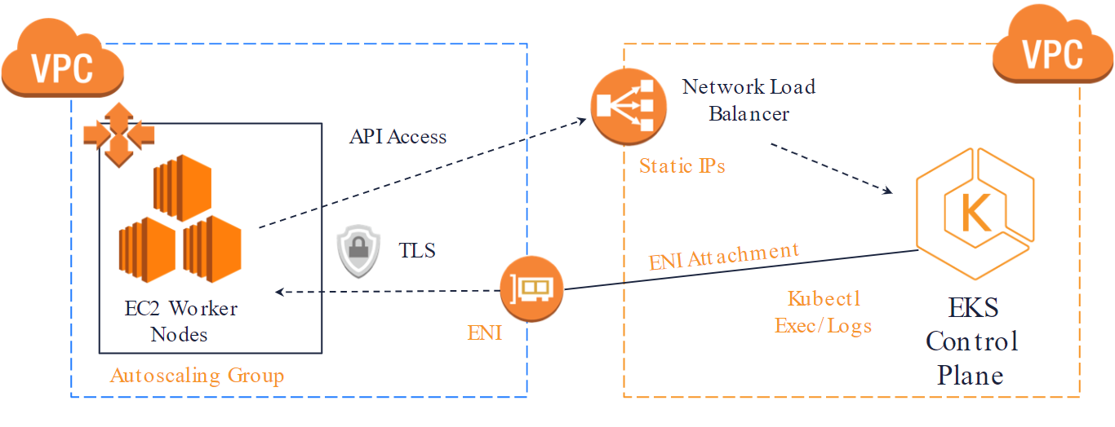

**Using EKSCTL:**

1. **Install EKSCTL**

#curl --silent --location "https://github.com/weaveworks/eksctl/releases/latest/download/eksctl_$(uname -s)_amd64.tar.gz" | tar xz -C /tmp

#sudo mv /tmp/eksctl /usr/local/bin

#eksctl version

